
AICW CAREER FOR WOMEN
Engineer HUB

FINANCIAL FRAUD DETECTION AND TRANSACTION PATTERN ANALYSIS USING ML
A Project Report
Submitted in partial fulfillment of the requirements of
AICW project.
by
K.MANASA
Manasakunja11@gmail.com
K.RAKSHITHA karrerakshitha944@gmail.com
B.AKSHITHA akshithaboragala@gmail.com

Under the Guidance of
Rapaka Manoj Kumar(SME)

ACKNOWLEDGEMENT

We would like to take this opportunity to express our deep sense of gratitude to all individuals who helped us directly or indirectly during this thesis work.

Firstly, we would like to thank my supervisor, Manoj Kumar Rapaka(SME), for being a great mentor and the best adviser I could ever have. His advice, encourage/ement and the critics area source of innovative ideas, inspiration and causes behind the successful completion of this project. The confidence shown in me by him was the biggest source of inspiration for me. It has been a privilege working with him for the last one year. Heal way helped me during my project and many other aspects related to the program. His talks and lessons not only help in project work and other activities of the program but also make me a good and responsible professional.

ABSTRACT

Financial fraud is difficult to detect because fraudulent transactions are rare, complex, and constantly changing. This project develops a real-time hybrid ML system using the PaySim dataset to detect fraudulent transactions and analyze transaction patterns. XGBoost is used for fraud detection, while a Temporal Graph Neural Network (TGN) models transaction behavior over time. Community detection helps identify potential fraud rings, SHAP provides model explanations, and ADWIN detects concept drift. A Streamlit dashboard presents fraud alerts, graph analysis, explanations, and system results. The system is evaluated using Precision, Recall, F1-score, and PR-AUC, providing an integrated approach to fraud detection, explainability, network analysis, and drift monitoring. The proposed system aims to support investigators by identifying suspicious transactions and connected fraud patterns more effectively. It also provides a foundation for adapting the detection process as transaction behavior changes over time.

TABLE OF CONTENTS
Abstract i
List of Figures ii
List of Tables iii
Chapter1.Introduction 1
Problem Statement 1
Motivation 1
Objectives 1
Scope of the Project 2
Chapter2.Literature Survey 3
Chapter3.Proposed Methodology 5
Chapter4.Implementation and Results 10
Chapter5.Discussion and Conclusion 13
References 15

LISTOF FIGURES

Figures | Title | Page No.
Figure 1 | System Architecture | 4
Figure 2 | System Design | 5
Figure 3 | DFD Level 0 Diagram | 7
Figure 4 | DFD Level 1 Diagram | 8
Figure 5 | PaySim Transaction Analysis | 11
Figure 6 | Transaction Graph and Fraud-Ring Detection | 13
Figure 7 | XGBoost and SHAP Results | 13
Figure 8 | Streamlit Fraud Detection Dashboard | 13

LISTOF TABLES

Tables | Title | Page No.
Table 1 | Dataset Specifications | 10
Table 2 | XGBoost Performance Metrics | 14
Table 3 | SHAP Feature Importance | 14
Table 4 | Fraud-Ring Summary | 14
Table 5 | ADWIN Drift Detection Results | 14

CHAPTER1

Introduction

Problem Statement:

Current fraud detection systems face challenges in accurately identifying fraudulent transactions due to the highly imbalanced, complex, and continuously changing nature of financial transaction data. Traditional methods may fail to detect evolving fraud patterns and connections between suspicious accounts, leading to financial losses and security risks. The lack of adaptive, explainable, and graph-based fraud detection mechanisms creates a critical need for a hybrid ML-based system that can detect fraudulent transactions, identify potential fraud rings, explain predictions, and adapt to changing transaction patterns.

Motivation:

The rapid growth of digital banking and online financial transactions has increased the risk of fraudulent activities, including unauthorized transfers, fake transactions, and money laundering. Traditional fraud detection methods may struggle to identify complex and evolving fraud patterns, especially when fraudulent transactions are rare compared to normal transactions.

To address this issue, this project focuses on using Artificial Intelligence and Machine Learning techniques to develop a hybrid fraud detection system. The system uses XGBoost to detect fraudulent transactions, TGN and transaction graphs to analyze relationships and identify potential fraud rings, SHAP for explainable predictions, and ADWIN to detect changing fraud patterns. The motivation behind this project is to improve fraud detection accuracy while providing explainability, network analysis, and adaptability to changing transaction behavior.

Objective:

The primary objective of this project is to design and develop an intelligent financial fraud detection system using Machine Learning techniques to accurately identify fraudulent transactions from normal transactions. By employing XGBoost for fraud classification and Temporal Graph Neural Networks (TGN) for transaction behavior analysis, the project aims to detect suspicious transactions and identify potential fraud patterns and connected fraud rings.

Another key objective is to enhance the effectiveness and adaptability of fraud detection by incorporating SHAP for explainable predictions, community detection for identifying fraud rings, and ADWIN for detecting changes in transaction patterns. The project also aims to demonstrate the practical application of AI in financial security through the development of a Streamlit-based fraud detection dashboard.

Scope of the Project:
The scope of this project includes the end-to-end implementation of an AI-based financial fraud detection and transaction analysis system, covering dataset preparation, transaction analysis, machine learning model training, fraud detection, transaction graph construction, and real-time fraud monitoring through a web-based dashboard. The system focuses on identifying fraudulent transactions, analyzing transaction patterns, detecting potential fraud rings, providing explainable predictions, and monitoring changes in fraud patterns.
However, the project is implemented as a prototype-level solution intended for academic and experimental purposes. Advanced features such as large-scale production deployment, integration with real banking systems, additional real-world datasets, and highly complex fraud scenarios are beyond the current scope. These limitations provide opportunities for future enhancement and expansion of the system.
.

CHAPTER2

Literature Survey

Review relevant literature or previous work in this domain.
Financial fraud detection has been widely studied using Machine Learning techniques to identify suspicious transactions. Traditional rule-based methods may struggle with complex and evolving fraud patterns.
Recent research uses XGBoost and other ML algorithms for transaction-level fraud detection, while Graph Neural Networks (GNNs) and TGN analyze relationships and transaction behavior over time. Community detection helps identify potential fraud rings, SHAP provides explainable predictions, and ADWIN detects changes in transaction patterns.
These approaches motivate an integrated system combining XGBoost, TGN, fraud-ring detection, SHAP, and ADWIN for effective and adaptive financial fraud detection.

Mention any existing models, techniques, or methodologies related to the problem.
Several techniques have been proposed for financial fraud detection. Traditional rule-based and statistical methods identify suspicious transactions using predefined patterns but may struggle with evolving fraud.
Machine Learning models such as XGBoost are widely used for transaction classification. Graph Neural Networks (GNNs) and TGN analyze relationships between accounts and transaction behavior over time. Community detection helps identify potential fraud rings, while SHAP provides explanations for model predictions. ADWIN can detect changes in transaction patterns.
These techniques form the basis of this project, which combines XGBoost, TGN, community detection, SHAP, and ADWIN for financial fraud detection and transaction pattern analysis.

Highlight the gaps or limitations in existing solutions and how your project will address them.
Existing financial fraud detection systems have several limitations. Traditional rule-based methods may fail to detect new and evolving fraud patterns. Machine Learning models mainly focus on individual transactions and may not capture relationships between accounts involved in fraudulent activities. Many systems also lack explainability and mechanisms to detect changes in transaction behavior.
The proposed project addresses these gaps by combining XGBoost for fraud detection, TGN for temporal transaction analysis, and community detection for identifying potential fraud rings. SHAP provides explanations for predictions, while ADWIN monitors changes in transaction patterns. A Streamlit dashboard integrates these components to provide an interactive and practical fraud detection system.

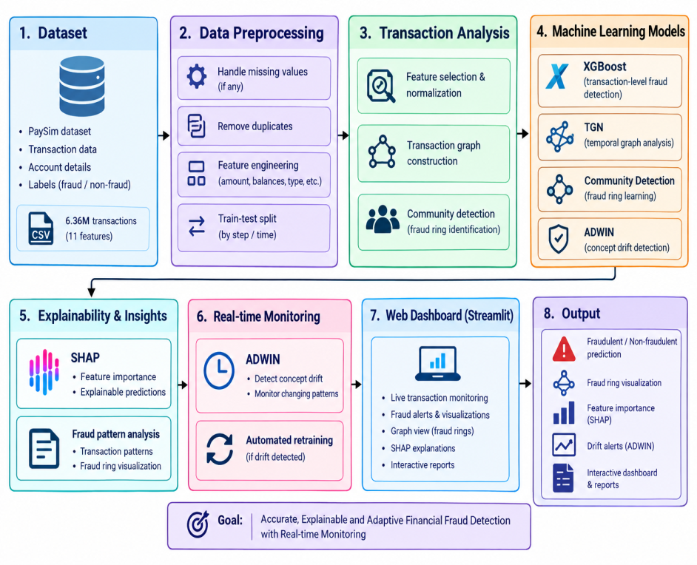
Fig.2.1 System Architecture

CHAPTER3

Proposed Methodology

System Design

The proposed system begins with the PaySim dataset, which contains transaction-related information used for fraud detection and transaction pattern analysis. The collected transaction data is first subjected to data preprocessing, where missing values, unnecessary attributes, and inconsistent data are handled. The processed data is then used for transaction-level analysis and model development.
The system uses XGBoost to classify transactions as legitimate or fraudulent. Along with transaction-level classification, a transaction graph is constructed by representing accounts as nodes and transactions as edges. This graph is analyzed using Temporal Graph Neural Networks (TGN) to capture transaction relationships and changes in transaction behavior over time.

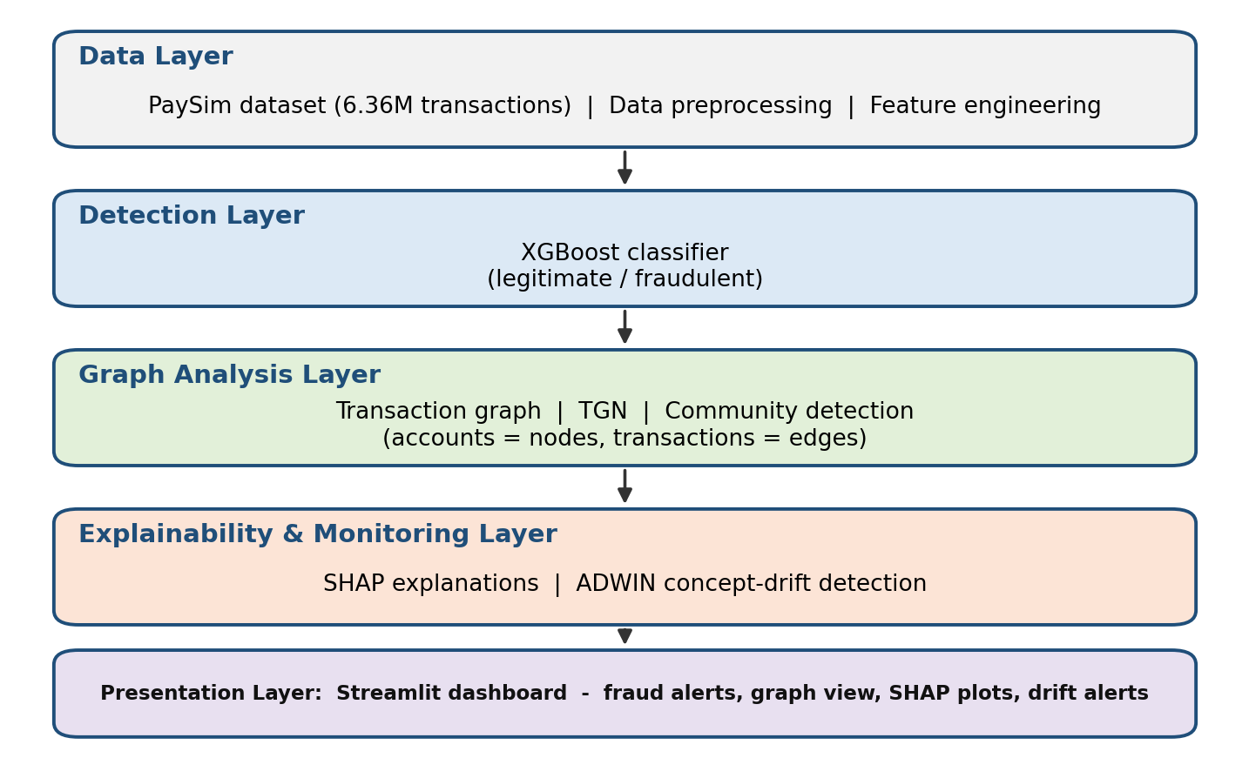
Fig.3.1 System Design
The overall design is organised into five layers. The data layer prepares the PaySim transactions, the detection layer classifies each transaction using XGBoost, the graph analysis layer studies relationships between accounts using TGN and community detection, the explainability and monitoring layer explains predictions with SHAP and watches for concept drift with ADWIN, and the presentation layer shows all results in a Streamlit dashboard. The main modules are described below.

Data Preprocessing :
The PaySim dataset is loaded and checked for missing values, duplicate records and inconsistent entries. Unnecessary identifier columns are removed from the model input, and categorical attributes such as the transaction type are encoded into numeric form. Additional features are derived from the transaction amount and the account balances before and after each transaction. Since the data is time ordered, the training and testing sets are created using the time step instead of a random split, so that the model is always tested on transactions that occur after the ones it was trained on.

Fraud Detection using XGBoost :
XGBoost is a gradient-boosted decision-tree algorithm that performs well on structured tabular data. In this project it is used as the transaction-level classifier that labels each transaction as legitimate or fraudulent. Because fraud is extremely rare in the dataset, class imbalance is handled by giving higher weight to the fraud class during training. The model is evaluated using Precision, Recall, F1-score and PR-AUC, which are more informative than accuracy on highly imbalanced data.

Transaction Graph Construction and TGN :
To capture relationships that a single-transaction view cannot show, the transactions are converted into a graph in which every account is a node and every transaction is a time-stamped edge carrying the amount and type. A Temporal Graph Neural Network (TGN) processes this stream of edges in time order and maintains a memory for every node, so the representation of an account is updated each time it takes part in a transaction. This allows the system to learn how the behavior of accounts and their connections changes over time.

Fraud Ring Detection using Community Detection :
Community detection algorithms (for example, Louvain) are applied to the transaction graph to group accounts that are densely connected to each other. Groups that contain a high share of suspicious transactions or show repeated transfers among the same accounts are reported as potential fraud rings. This helps investigators look at a connected group of accounts rather than at isolated transactions.

Explainability using SHAP :
SHAP (SHapley Additive explanations) assigns every input feature a contribution value for each prediction. Global SHAP plots show which features influence the fraud decision most across the dataset, while local plots explain why one particular transaction was flagged. These explanations make the system more transparent and easier for an investigator to trust.

Concept Drift Detection using ADWIN :
Fraud behavior changes over time, so a model that was accurate earlier can slowly lose performance. ADWIN (Adaptive Windowing) monitors a stream of values such as the model error or prediction score, keeps a window of recent data, and signals a drift when the average in two parts of the window differs significantly. A drift alert indicates that the model may need to be retrained on newer transactions.

Streamlit Dashboard :
The results of all modules are presented in a web-based Streamlit dashboard. It displays fraud alerts and risk scores, the transaction graph with detected fraud rings, SHAP explanations, drift alerts and the evaluation results, so that the whole detection process can be monitored from one place.

Data Flow Diagram
A Data Flow Diagram (DFD) represents the movement of data within the system. It shows how transaction data flows from the data source through the different processing stages and how the results reach the investigator. The DFD is drawn at different levels of detail, which makes the functionality of the system easier to understand and analyse.

DFD Level 0 :
DFD Level 0 gives a high-level overview of the system as a single process. The PaySim transaction data enters the system, and the fraud analyst receives fraud alerts, risk scores, explanations, graphs and reports. The internal details of the system are not shown at this level.
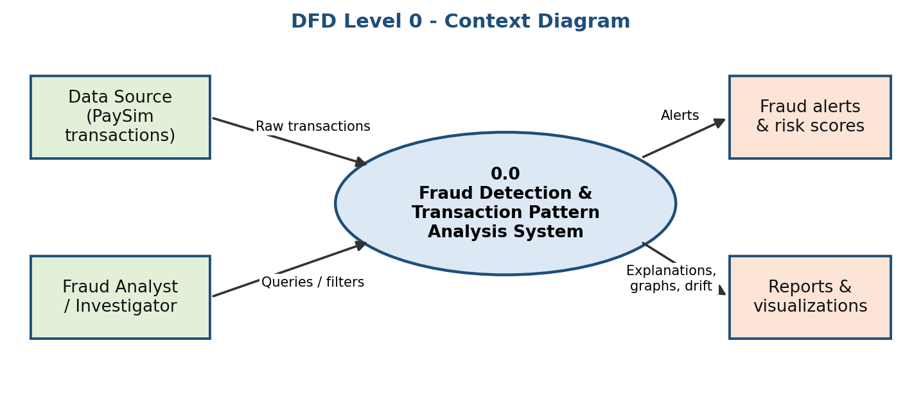
Fig.3.2 DFD Level 0 Diagram

DFD Level 1 - Main System Processes:
Level 1 breaks the system into its main processes: data preprocessing (1.0), fraud classification with XGBoost (2.0), graph construction and TGN analysis (3.0), community detection for fraud rings (4.0), SHAP explanation (5.0), ADWIN drift monitoring (6.0) and the Streamlit dashboard (7.0). Processed data and trained models are kept in two data stores, D1 and D2.
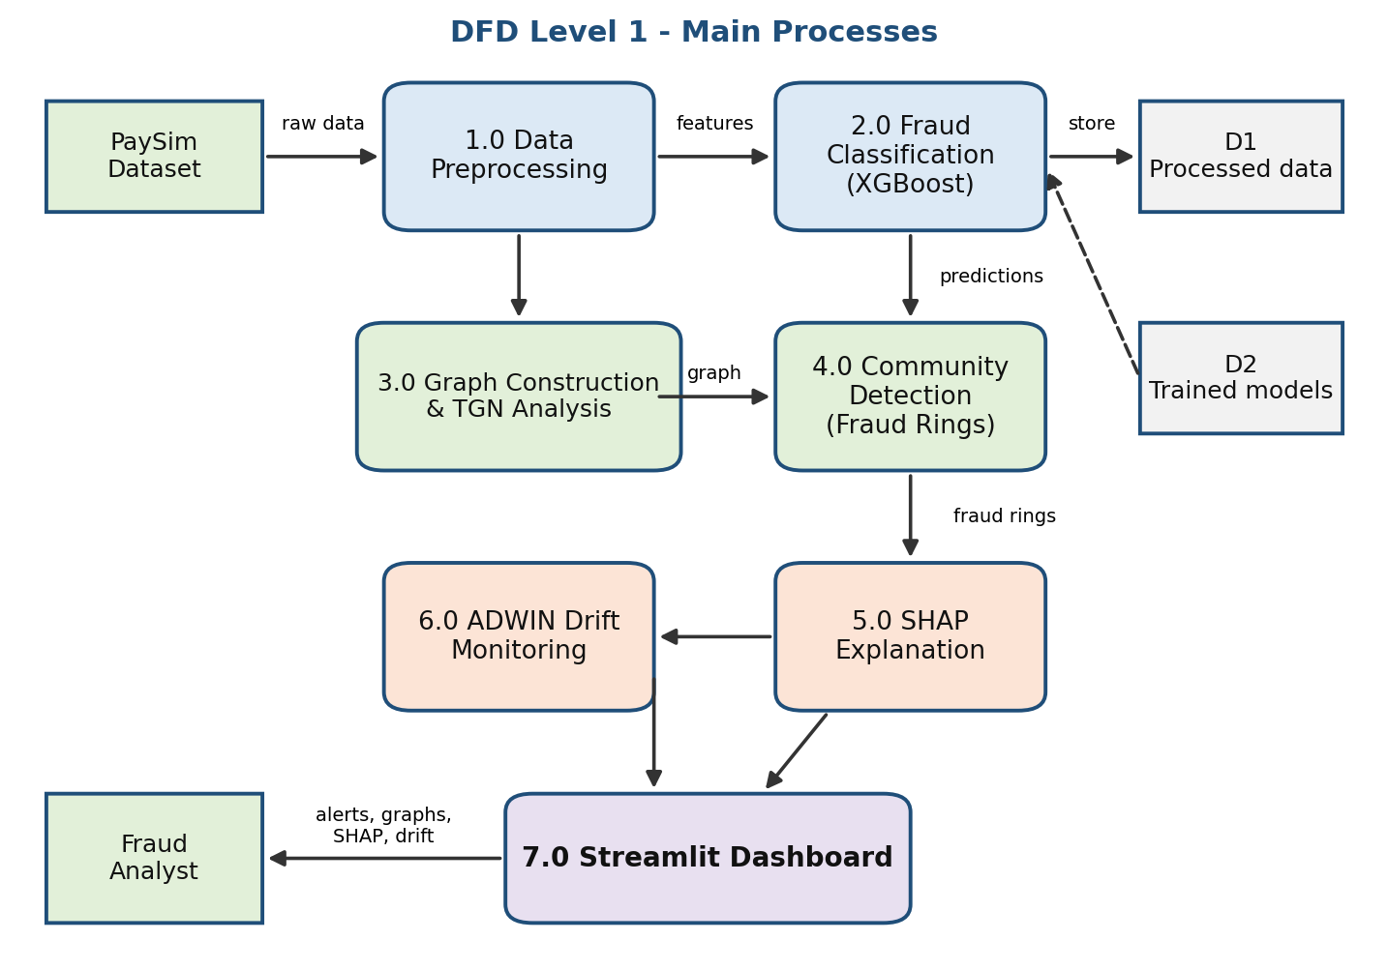
Fig.3.3 DFD Level 1 Diagram

DFD Level 2 - Fraud Detection and Explanation Module :
This level expands processes 2.0 and 5.0. The preprocessed features are passed to the trained XGBoost model, which produces a fraud probability for each transaction. A decision threshold converts the probability into a fraud or legitimate label, and the SHAP module then calculates the feature contributions that explain the decision. The label, the score and the explanation are sent to the dashboard.

DFD Level 3 - Graph Analysis and Drift Monitoring Module :
This level expands processes 3.0, 4.0 and 6.0. Transactions are converted into a temporal graph, TGN updates the node memories, and community detection groups closely connected accounts into potential fraud rings. In parallel, ADWIN monitors the model performance stream and raises a drift alert when the transaction pattern changes, so that the model can be updated.

Advantages
The proposed system offers several advantages:

- Detects fraudulent transactions accurately even when fraud cases are extremely rare
- Identifies connected groups of accounts (fraud rings) instead of only single transactions
- Provides explainable predictions using SHAP, which helps investigators trust the alerts
- Adapts to changing fraud behavior by monitoring concept drift with ADWIN
- Presents alerts, graphs and explanations in an easy-to-use Streamlit dashboard
- Modular design that can be extended with new models, features and datasets

Requirement Specification

Hardware Requirements :
- Processor: Intel Core i5 or higher (Intel Core i3 as minimum)
- RAM: Minimum 8 GB (16 GB recommended for processing the full PaySim dataset)
- Storage: Minimum 20 GB free disk space
- GPU (optional): NVIDIA GPU with CUDA support to speed up TGN training
- Display: Standard monitor with minimum resolution of 1366 × 768

These specifications are sufficient for preprocessing the dataset, training the XGBoost and TGN models, and running the web-based dashboard.

Software Requirements :
- Operating System: Windows / Linux / macOS
- Programming Language: Python 3.x
- Development Environment: VS Code / PyCharm / Jupyter Notebook / Google Colab
- Data Processing Libraries: Pandas, NumPy, Scikit-learn
- Machine Learning Libraries: XGBoost, PyTorch (TGN implementation)
- Graph Libraries: NetworkX, PyTorch Geometric
- Explainability and Drift Detection: SHAP, River (ADWIN)
- Visualization and Web Framework: Matplotlib, Plotly, Streamlit
- Browser: Google Chrome or any modern web browser

CHAPTER4

Implementation and Results

Implementation Details
The system was implemented in Python in the following order: (1) the PaySim dataset was loaded and preprocessed, (2) transaction patterns were analysed, (3) the XGBoost classifier was trained and evaluated, (4) SHAP was applied to explain the predictions, (5) the transaction graph was built and analysed with TGN and community detection, (6) ADWIN was used to monitor changes in the transaction pattern, and (7) all outputs were integrated into a Streamlit dashboard for real-time monitoring.

Dataset Description
The project uses the PaySim dataset, a synthetic financial dataset generated by a simulator that reproduces the behavior of mobile-money transactions using aggregated data from a real financial service. Because real transaction data is confidential, PaySim provides a safe and realistic alternative for fraud detection research. The main specifications of the dataset are given in Table 1.

Table 1: Dataset Specifications
No. | Parameter | Description
1 | Dataset | PaySim - synthetic mobile-money transaction dataset
2 | Total transactions | 6,362,620
3 | Number of attributes | 11 (including the fraud label)
4 | Time span | 743 steps (1 step = 1 hour, approximately 30 days)
5 | Transaction types | CASH_IN, CASH_OUT, DEBIT, PAYMENT, TRANSFER
6 | Fraudulent transactions | 8,213 (approximately 0.13%)
7 | Legitimate transactions | 6,354,407
8 | Fraud occurs in | TRANSFER and CASH_OUT transactions only
9 | Target variable | isFraud (1 = fraud, 0 = legitimate)

Data Preprocessing and Transaction Analysis
Before model training, the data was checked for missing values and duplicates, and the features were prepared as described in Chapter 3. The analysis of the transactions shows that the dataset is extremely imbalanced: only about 0.13% of the transactions are fraudulent. It also shows that fraud appears only in TRANSFER and CASH_OUT transactions, as illustrated in Fig.4.1. This observation guides feature engineering and confirms that accuracy alone is not a suitable metric, so Precision, Recall, F1-score and PR-AUC are used to evaluate the model.
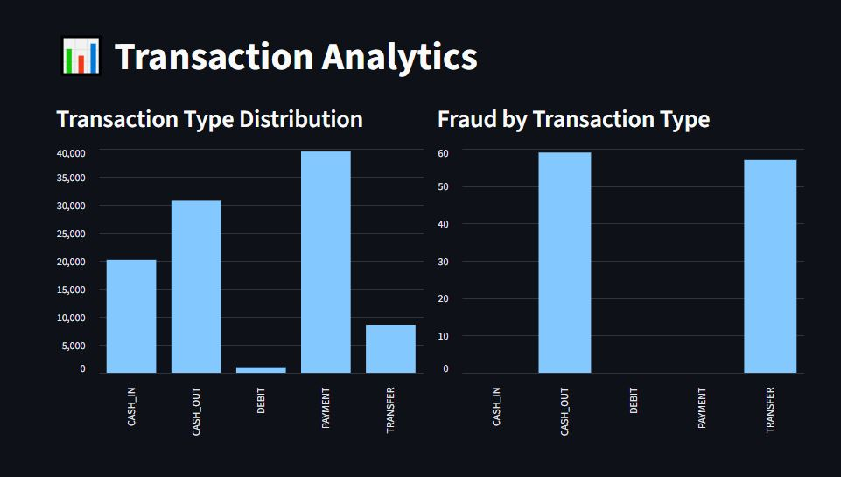
Fig.4.1 PaySim Transaction Analysis

Results of Fraud Detection using XGBoost
The XGBoost classifier was trained on the earlier time steps and tested on the later time steps of the dataset. Its performance on the test set is reported in Table 2 in the Evaluation Metrics section, together with the confusion matrix and the precision-recall curve shown in the output screens. Recall shows how many of the real fraud cases are caught, Precision shows how many of the raised alerts are correct, and PR-AUC summarises the trade-off between them across all thresholds.

Results of SHAP Explanation
SHAP was applied to the trained XGBoost model to find out which features drive the fraud predictions. The summary plot ranks the features by their average contribution, and individual explanation plots show why a specific transaction was flagged. Typical influential features in this dataset are the transaction amount, the balances of the sender and the receiver before and after the transaction, and the transaction type. The feature importance values are listed in Table 3.

Results of Transaction Graph and Fraud-Ring Detection
The transactions were converted into a graph of accounts and transfers, and TGN was used to model how account behavior changes over time. Community detection was then applied to group closely connected accounts. Communities that contain a large number of suspicious transactions were reported as potential fraud rings and are summarised in Table 4. The graph view in the dashboard allows the investigator to explore each ring and the accounts connected to it.

Results of ADWIN Drift Detection
ADWIN was used to monitor the stream of model errors over time. When the average error in the recent window differs significantly from the earlier window, a drift is signalled, meaning that the transaction pattern has changed and the model may need to be retrained. The drift points detected are shown in Table 5.

Streamlit Fraud Detection Dashboard
The dashboard integrates all modules in a single web interface. It shows live transaction monitoring with fraud alerts, the transaction graph with detected fraud rings, SHAP explanations for flagged transactions, ADWIN drift alerts and the evaluation results. The screenshots of the dashboard are given in the output screens.

OUTPUT SCREENS:
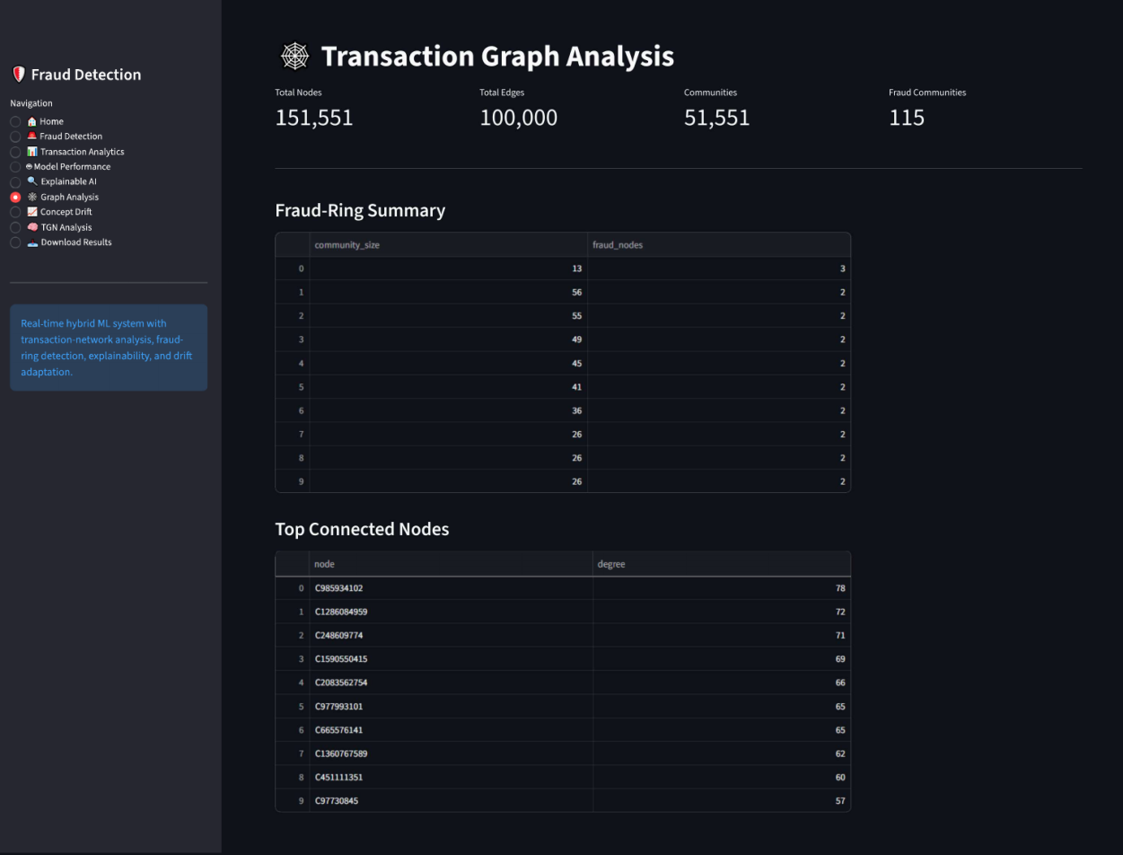
Fig.4.2 Transaction Graph and Fraud-Ring Detection
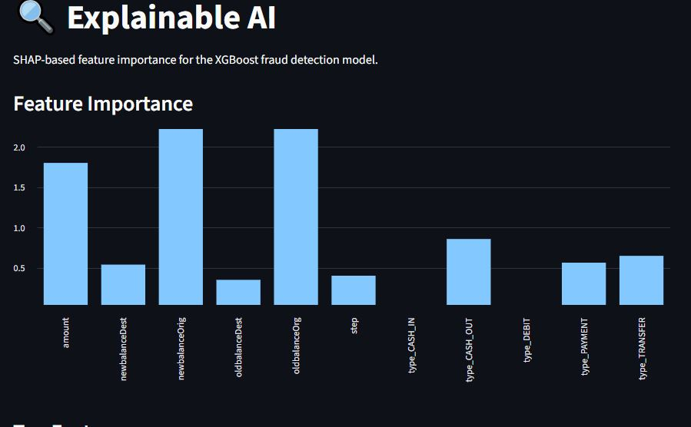
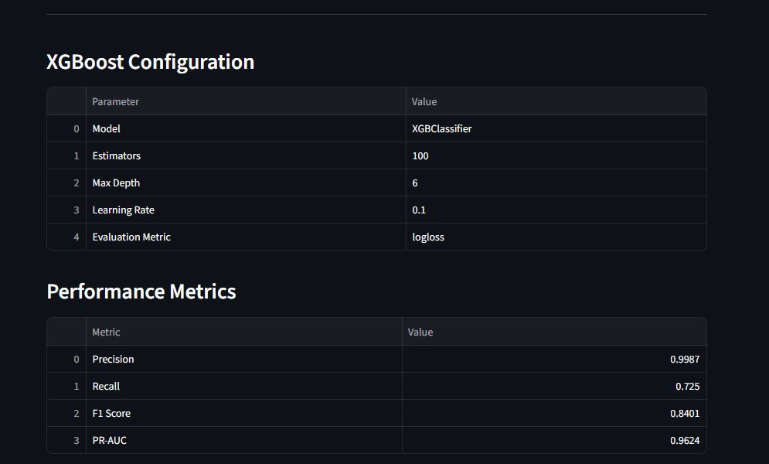
Fig.4.3 XGBoost and SHAP Results
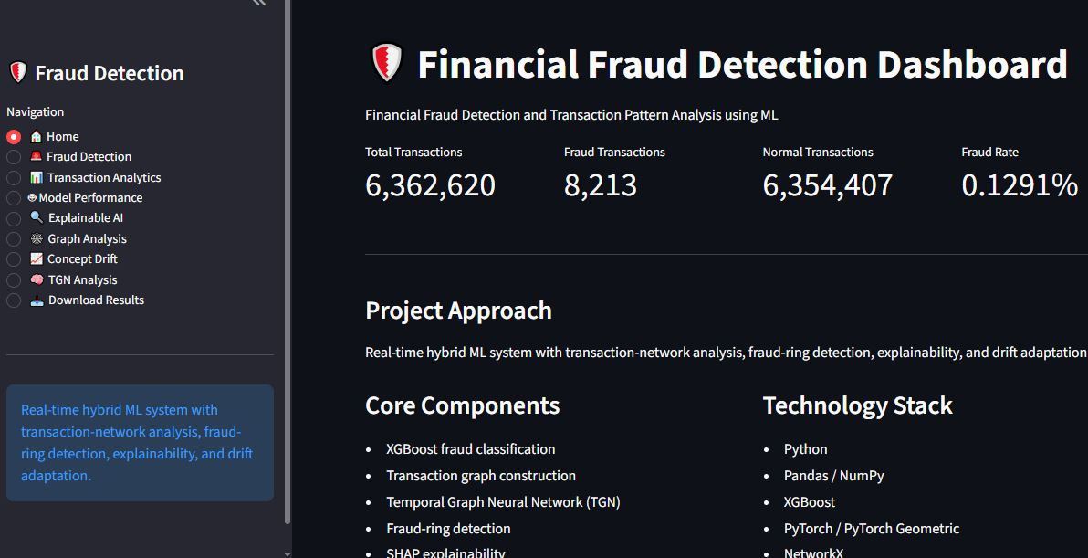
Fig.4.4 Streamlit Fraud Detection Dashboard

Evaluation Metrics
Table 2 lists the metrics used to evaluate the XGBoost fraud detector on the test data. Table 3 gives the SHAP feature importance, Table 4 the fraud rings found in the transaction graph, and Table 5 the drift points detected by ADWIN.

Table 2: XGBoost Performance Metrics
No. | Metric Name | Description | Value
1 | Precision | Fraction of transactions flagged as fraud that are truly fraud | 0.9987
2 | Recall | Fraction of actual fraud transactions that were detected | 0.7250
3 | F1-Score | Harmonic mean of Precision and Recall | 0.8401
4 | PR-AUC | Area under the Precision-Recall curve (suited to imbalanced data) | 0.9624

Table 3: SHAP Feature Importance
No. | Feature | Description | Mean |SHAP| value
1 | amount | Transaction amount | 1.801462
2 | oldbalanceOrg | Sender balance before the transaction | 2.556188
3 | newbalanceOrig | Sender balance after the transaction | 2.655647
4 | oldbalanceDest | Receiver balance before the transaction | 0.351191
5 | newbalanceDest | Receiver balance after the transaction | 0.540029
6 | type | Transaction type (TRANSFER / CASH_OUT, etc.) | 0.648745  0.857677

Table 4: Fraud-Ring Summary
Ring ID | Accounts in ring | Transactions | Total amount | Fraud ratio
16 | 2 | 1 | 35,063.63 | 1.00
28 | 2 | 1 | 1,096,187.24 | 1.00
29 | 2 | 1 | 963,532.14 | 1.00

Table 5: ADWIN Drift Detection Results
Drift No. | Time step / window | Monitored metric | Action taken
1 | 95,999 | XGBoost prediction probability | Drift detected
2 | 97,727 | XGBoost prediction probability | Drift detected
3 | 97,951 | XGBoost prediction probability | Drift detected
4 | 98,495 | XGBoost prediction probability | Drift detected
5 | 472,415 | XGBoost prediction probability | Drift detected

CHAPTER 5

Discussion and Conclusion

Key Findings:
The primary objective of this project was to design a hybrid machine-learning system that detects fraudulent transactions and analyses transaction patterns using the PaySim dataset. The results show that combining transaction-level classification with graph-based analysis gives a broader view of fraud than either approach alone. XGBoost handles the highly imbalanced data and flags suspicious transactions, while the transaction graph, TGN and community detection reveal connected groups of accounts that may operate as fraud rings. SHAP makes the predictions understandable for investigators, ADWIN shows when the transaction behavior changes, and the Streamlit dashboard brings all these outputs together in one interface. Because fraud makes up only about 0.13% of the transactions, Precision, Recall, F1-score and PR-AUC were used instead of accuracy to judge the model.
GitHub Link of the Project:
https://github.com/akshithaboragala/Financial-Fraud-Detection
Video Recording of Project:
https://drive.google.com/file/d/1q7SiyVBTEFMfeWwyeBm467-L2oi27N_9/view?usp=sharing
Limitations:
Despite its advantages, the proposed system has certain limitations. The PaySim dataset is synthetic, so the results may not fully represent the behavior of real banking transactions. The system is a prototype-level solution built for academic and experimental purposes and has not been integrated with real banking systems or tested under large-scale production traffic.
Training a temporal graph model on millions of transactions needs considerable computing resources, and fraud detection on extremely imbalanced data always involves a trade-off between missing fraud cases and raising false alarms. In addition, the drift monitoring is evaluated on the available dataset rather than on a live transaction stream.
Future Work:
Future enhancements can further improve the system. It can be tested on additional real-world or benchmark datasets and extended to handle more complex fraud scenarios. The prototype can be connected to a streaming platform for true real-time scoring, and the retraining process can be automated so that the model updates itself when ADWIN detects a drift.
Other improvements include experimenting with additional graph neural network models, adding an alert-management workflow for investigators, and deploying the dashboard in a scalable, secure environment with proper protection of customer data.
Conclusion:
This project successfully demonstrates an integrated approach to financial fraud detection and transaction pattern analysis using machine learning. By combining XGBoost for classification, TGN and community detection for network analysis, SHAP for explainability and ADWIN for drift monitoring, the system detects suspicious transactions, identifies potential fraud rings, explains its decisions and adapts to changing transaction behavior.
The project highlights that artificial intelligence can be used effectively for financial security, and it provides a strong foundation for future research and for the development of more robust, explainable and adaptive fraud detection systems.

REFERENCES

- Chen, T., & Guestrin, C. (2016). XGBoost: A Scalable Tree Boosting System. Proceedings of the 22nd ACM SIGKDD International Conference on Knowledge Discovery and Data Mining.
- Rossi, E., Chamberlain, B., Frasca, F., Eynard, D., Monti, F., & Bronstein, M. (2020). Temporal Graph Networks for Deep Learning on Dynamic Graphs. arXiv preprint arXiv:2006.10637.
- Lundberg, S. M., & Lee, S.-I. (2017). A Unified Approach to Interpreting Model Predictions. Advances in Neural Information Processing Systems (NeurIPS).
- Bifet, A., & Gavaldà, R. (2007). Learning from Time-Changing Data with Adaptive Windowing. Proceedings of the SIAM International Conference on Data Mining.
- Lopez-Rojas, E. A., Elmir, A., & Axelsson, S. (2016). PaySim: A Financial Mobile Money Simulator for Fraud Detection. 28th European Modeling and Simulation Symposium (EMSS).
- Blondel, V. D., Guillaume, J.-L., Lambiotte, R., & Lefebvre, E. (2008). Fast Unfolding of Communities in Large Networks. Journal of Statistical Mechanics: Theory and Experiment.
- Saito, T., & Rehmsmeier, M. (2015). The Precision-Recall Plot Is More Informative than the ROC Plot When Evaluating Binary Classifiers on Imbalanced Datasets. PLoS ONE, 10(3).
- Kipf, T. N., & Welling, M. (2017). Semi-Supervised Classification with Graph Convolutional Networks. International Conference on Learning Representations (ICLR).
- Streamlit Documentation - Open-source framework for building data and machine learning web apps.
- SHAP, XGBoost, River and PyTorch Geometric official documentation.

Appendices

Appendix A: XGBoost Model Training (Sample Implementation)
The following sample code shows how the XGBoost classifier can be trained with class-imbalance handling and evaluated using Precision, Recall, F1-score and PR-AUC.

import pandas as pd
from xgboost import XGBClassifier
from sklearn.metrics import (precision_score, recall_score,
f1_score, average_precision_score)

df = pd.read_csv("PaySim.csv")
df = pd.get_dummies(df, columns=["type"])
X = df.drop(columns=["isFraud", "isFlaggedFraud", "nameOrig", "nameDest"])
y = df["isFraud"]

# time-based split using the "step" column
train = df["step"] <= 600
X_train, y_train = X[train], y[train]
X_test, y_test = X[~train], y[~train]

ratio = (y_train == 0).sum() / (y_train == 1).sum()
model = XGBClassifier(n_estimators=300, max_depth=6, learning_rate=0.1,
scale_pos_weight=ratio, eval_metric="aucpr")
model.fit(X_train, y_train)

prob = model.predict_proba(X_test)[:, 1]
pred = (prob >= 0.5).astype(int)
print("Precision:", precision_score(y_test, pred))
print("Recall :", recall_score(y_test, pred))
print("F1-score :", f1_score(y_test, pred))
print("PR-AUC :", average_precision_score(y_test, prob))

Appendix B: Evaluation Metric Formulas
Let TP, FP, TN and FN denote true positives, false positives, true negatives and false negatives, where a "positive" is a fraudulent transaction.

- Precision = TP / (TP + FP)
- Recall = TP / (TP + FN)
- F1-score = 2 × (Precision × Recall) / (Precision + Recall)
- PR-AUC = area under the curve of Precision plotted against Recall over all thresholds

Appendix C: PaySim Dataset Attributes
No. | Attribute | Description
1 | step | Unit of time; 1 step = 1 hour (743 steps in total)
2 | type | Transaction type: CASH_IN, CASH_OUT, DEBIT, PAYMENT, TRANSFER
3 | amount | Amount of the transaction in local currency
4 | nameOrig | Customer who started the transaction
5 | oldbalanceOrg | Initial balance of the sender before the transaction
6 | newbalanceOrig | Balance of the sender after the transaction
7 | nameDest | Recipient of the transaction
8 | oldbalanceDest | Initial balance of the recipient before the transaction
9 | newbalanceDest | Balance of the recipient after the transaction
10 | isFraud | Label: 1 if the transaction is fraudulent, otherwise 0
11 | isFlaggedFraud | Flag set by the simulator for illegal large transfers

Appendix D: ADWIN Drift Monitoring (Sample Implementation)
The sample code below shows how ADWIN from the River library can monitor a stream of prediction errors and report the points where a drift occurs.

from river import drift

adwin = drift.ADWIN()
# errors: 1 if the prediction was wrong, 0 if it was correct
for i, err in enumerate(errors):
adwin.update(err)
if adwin.drift_detected:
print(f"Concept drift detected at index {i}")

